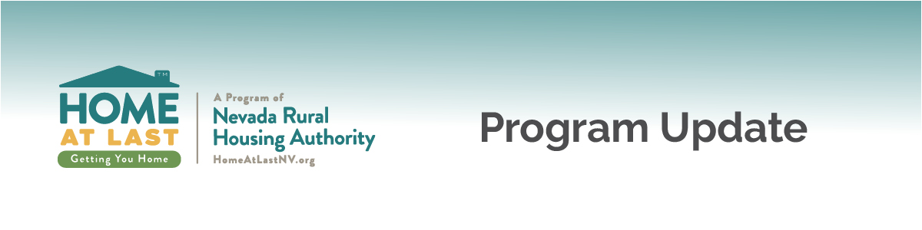
Issue Date: August 9, 2019
Effective Date: September 3, 2019
Update No.: 2019-01
Updated Guidelines for Manufactured Housing Loans
Summary | Lenders will be responsible for ensuring compliance with the new U.S. Bank manufactured housing requirements for loans reserved on or after September 3, 2019. The U.S. Bank requirements will apply only to loans used for the purchase or refinance of existing and new manufactured homes.
Requirements | - Minimum FICO score will increase from 640 to 680 for all Government manufactured housing loans (FHA, VA, USDA)  - Minimum FICO score will remain 640 for Fannie Mae Conventional manufactured housing loans  - Maximum debt-to-income (DTI) ratio will be 45% for Government and Conventional manufactured housing loans  - Manual underwriting for Government and Conventional manufactured housing loans will no longer be accepted by U.S. Bank
Questions | Please contact our office at (775) 283-0173 or email HAL@NVRural.org for more information about this update.  Visit the eHousing Portal for full program guidelines. The updated guidelines will be posted on or before September 3, 2019.

