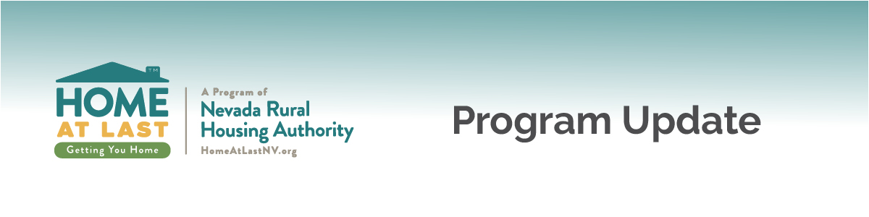
Date: August 23, 2019
Update No.: 2019-02
Refinancing Guidelines
Summary | The benefits of recent interest rate drops affect not only homebuyers but homeowners in the market for refinancing options. This program update serves as clarification for the Home At Last refinance options permitted in the program.  U.S. Bank will accept refinance loans subject to the requirements listed below. Note that interest rates and assistance options for refinances are the same as for purchases. Lender must also follow all loan type guidelines (FHA, VA, etc.) and U.S. Bank property type guidelines, as applicable.
Requirements | - No FHA Streamline loans  - 640 minimum FICO score  - 45% Maximum DTI  - No Cash Out  - Non-US Bank portfolio serviced loans  - Maximum principal curtailment $1,000
Questions | Please contact our office at (775) 283-0173 or email HAL@NVRural.org for more information about this update.

